**ACTIVITY TRACKING MODULE**

**USER MANUAL**

Version: 1.1

Prepared by: Poni Augustina

Date: 30/Jan/2018

**Getting started:**

Open Activity Tracking Module (ATM) using any web browser e.g. Google Chrome or Mozilla Firefox by entering the IP address of the server 10.200.254.73 as the URL. This will bring a page requesting for login information that you enter to proceed.

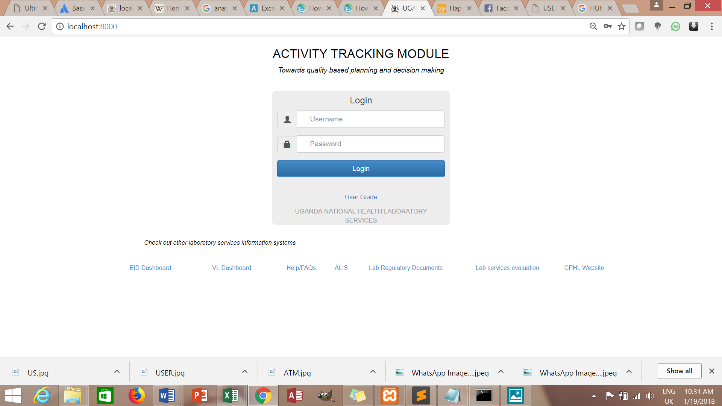

Fill in the username and password 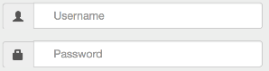 then click 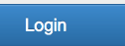

When you don’t fill in either of the username or password, you will get errors as displayed below

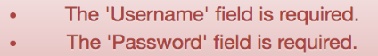

When you fill in wrong username or password, the following errors shall be displayed

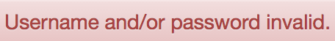

When you forgot your username and password, kindly contact the lab-in-charge for help.

The page below will appear on successful login and it is the ATM Landing page

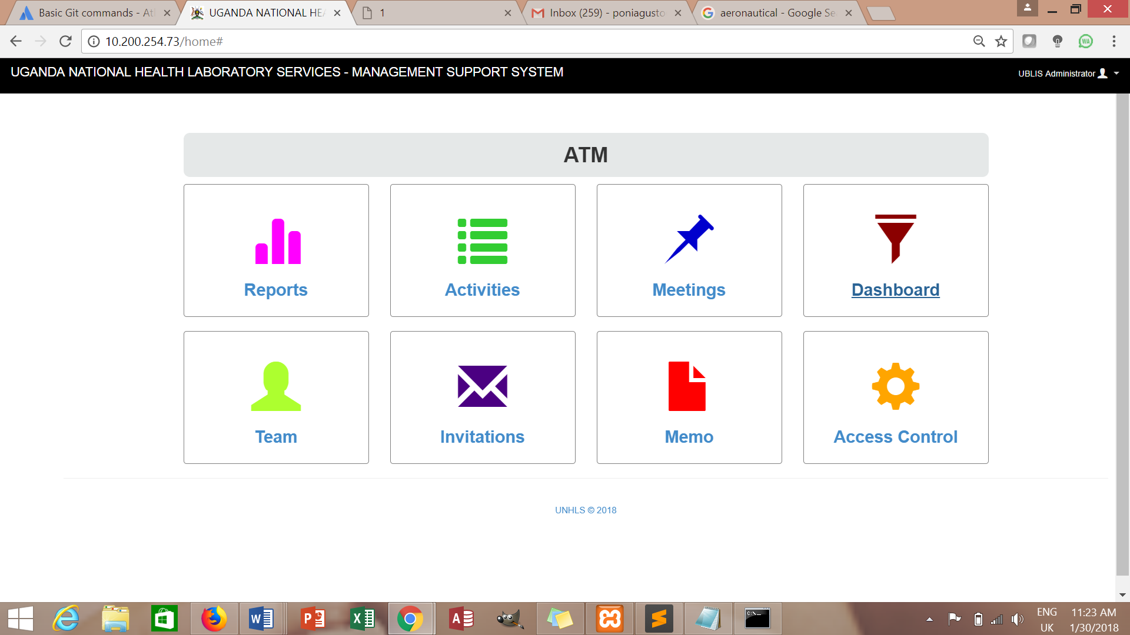

The main parts of the system are:

* Access Control

Access control is used for:

* Adding, editing and viewing user accounts
* Adding, editing, viewing and deleting roles
* Assigning roles to user accounts
* Assigning permissions to the roles
* Reports

Used for:

* Viewing and downloading field reports from activity
* Viewing and downloading minutes from meetings
* Analytical purposes
* Activity log

Used for:

* Listing all captured activities
* Adding new activity/event
* Searching for an activity
* Meeting log

Used for:

* Listing captured meetings
* Adding meeting
* Memo

This section deals with information in writing sent by one person or department to the Executive Director seeking for approval of an event/activity

Used for:

* Listing written memos
* Writing a memo
* Invitations

This section deals with information in writing sent by one person to the Executive Director seeking for approval to attend an external activity with an attachment of the invitation.

Used for:

* Listing captured invitations
* Creating new invitation
* Team

Lists staff in the senior management team

* Dashboard

Used for:

* Showing statistics

**Creating new user**

Click Access Control from the page (far right lower box) or  on the left menu bar, then click on 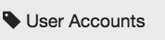, then click on 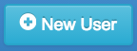 and fill in the form below and click on **Save**

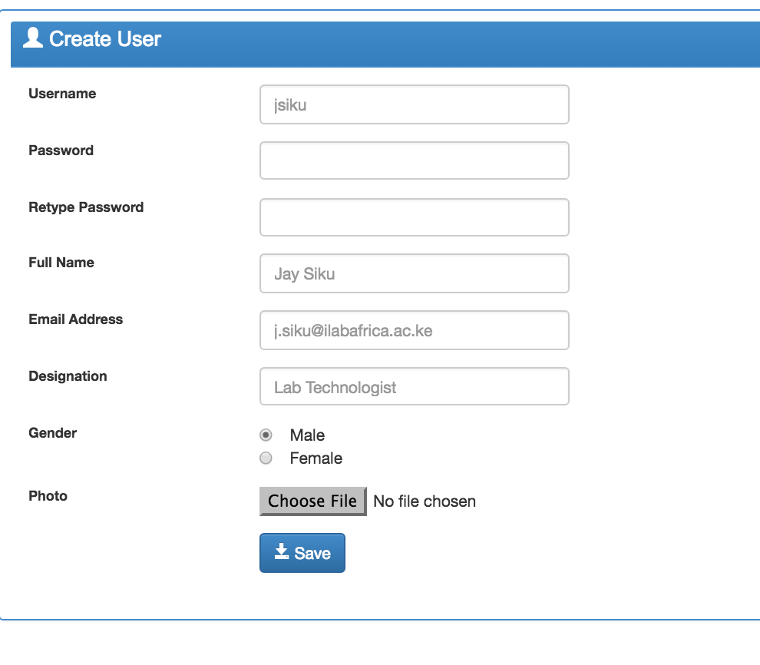

**Creating a role**

To create a new role in the system e.g. Receptionist, Data clerk; Under Access Control click on roles 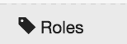 to bring a page below

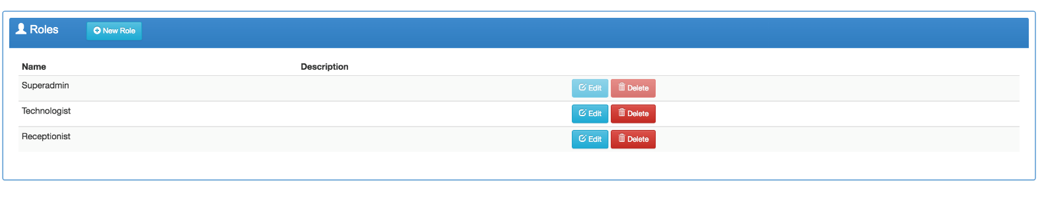

Then click on New Role to fill in the form below and click **Save**

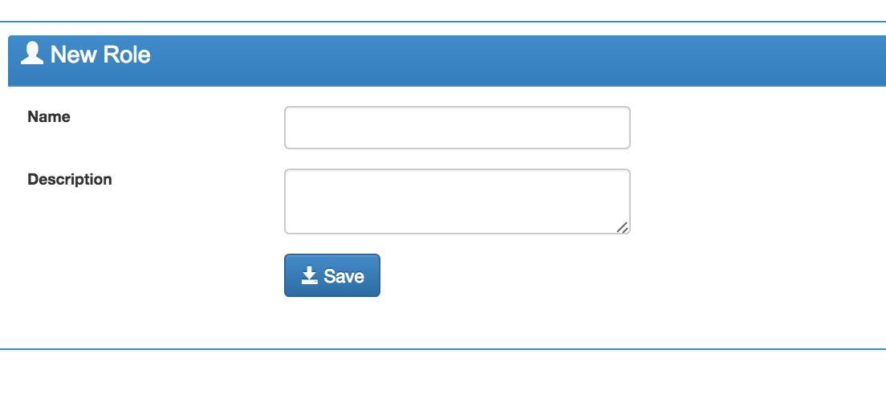

3

**Assigning a Role to the user**

Under Access Control click on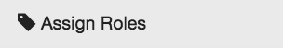, check the relevant role for the newly created user and click **Save**

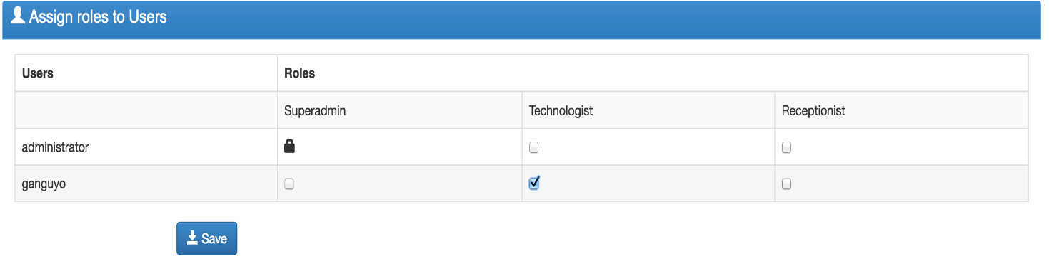

**Assigning permissions to Roles**

Under Access Control click on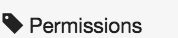, check the appropriate permissions as shown below and click **Save**

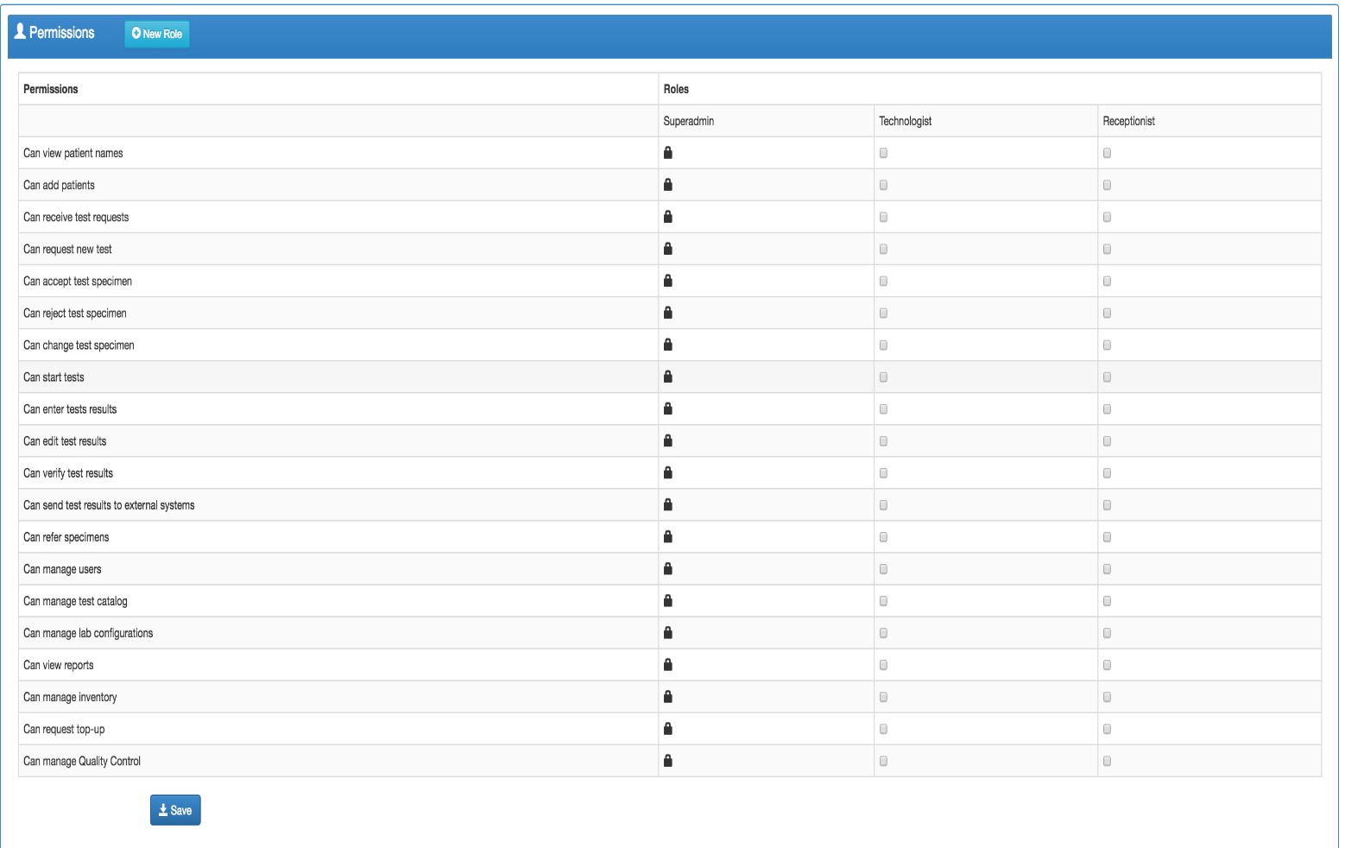

**Changing a Password**

Click on your Username in the top right of your screen, then click on , select the **Change Password** tab and fill in the form below and click **Update.**

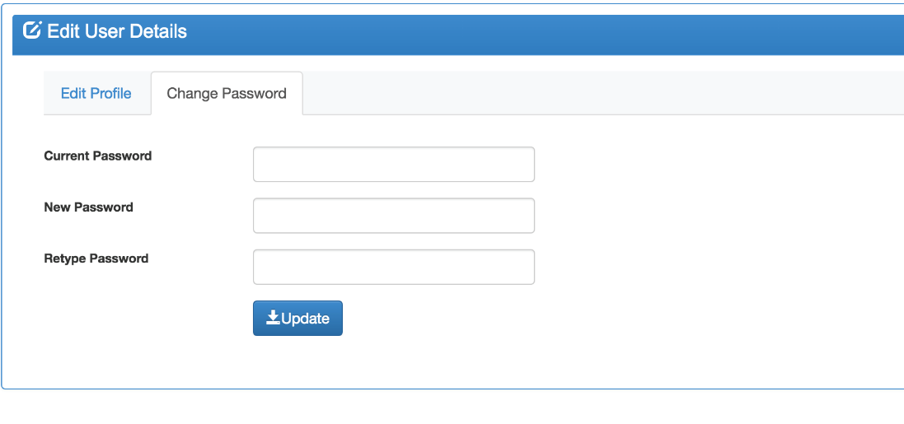

**Logging out**

Click on your Username in the top right of your screen, and then click on

**Creating a new Thematic Area/Department**

Click 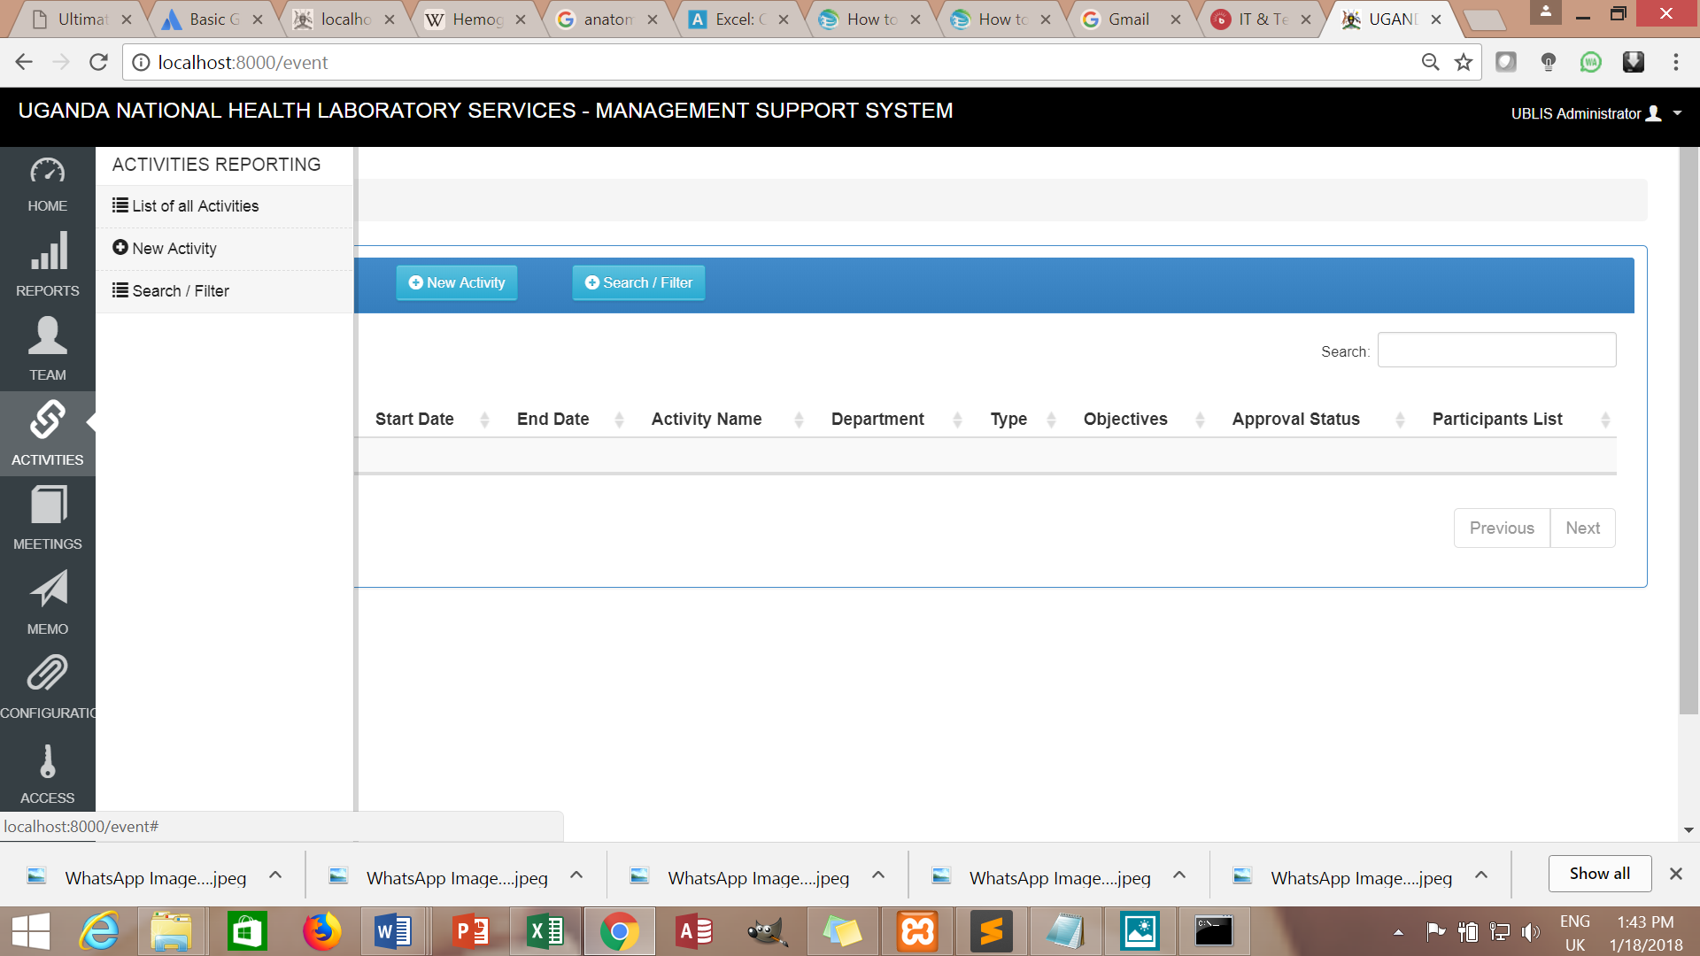 on the left menu bar, then click on 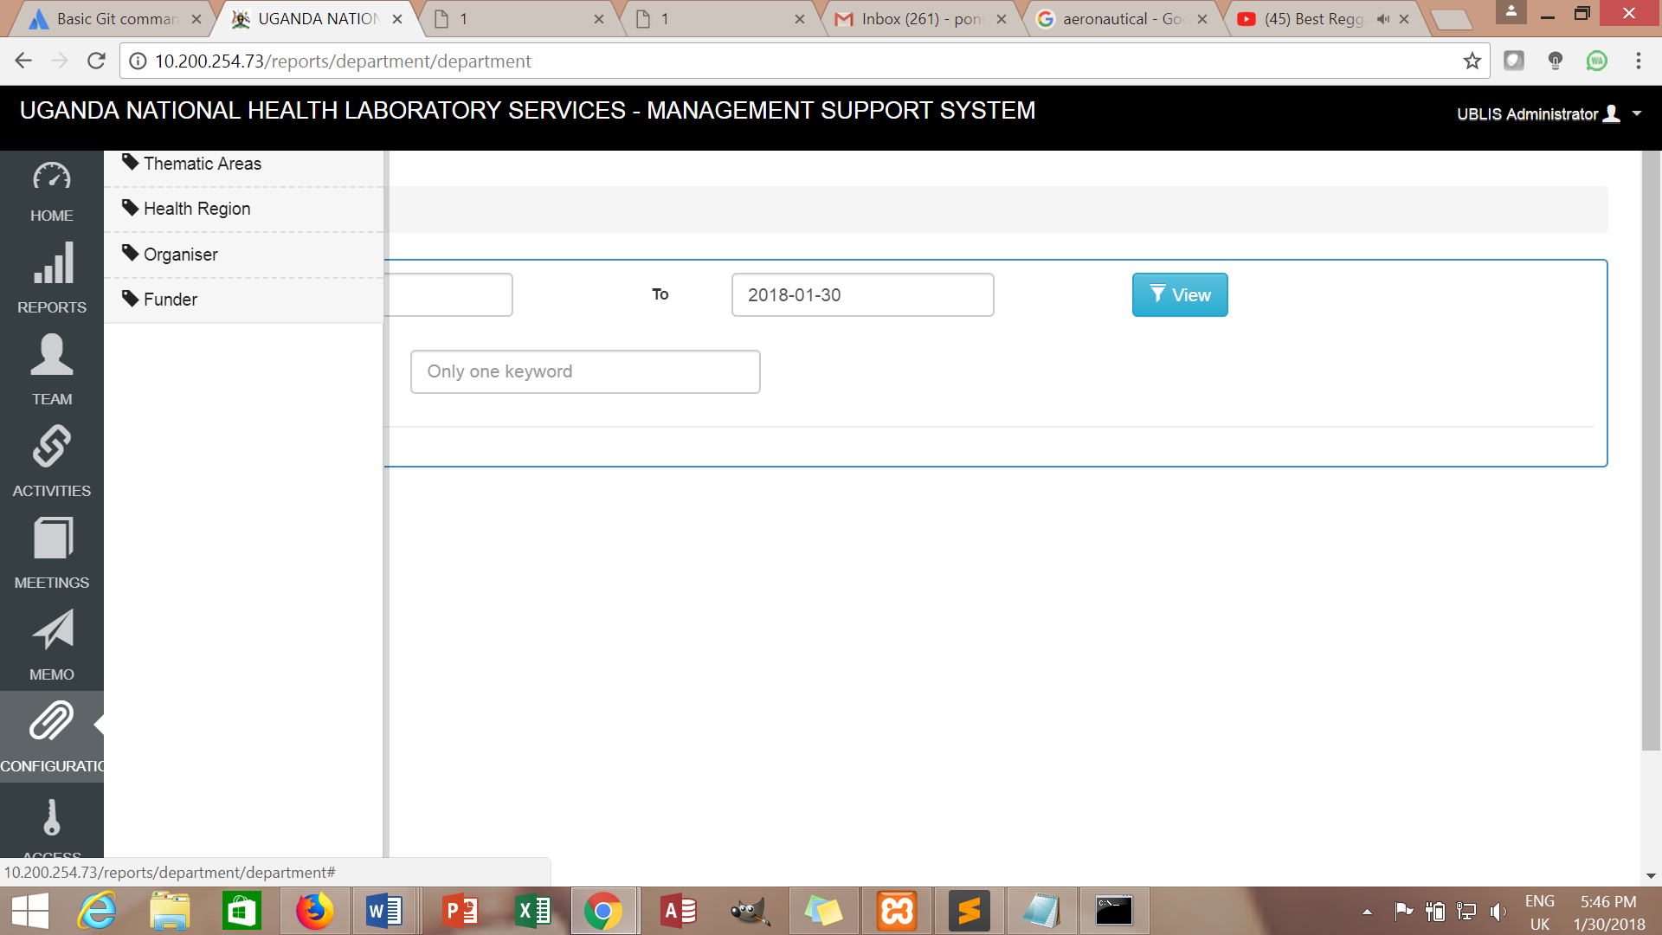 and click on New Thematic Area

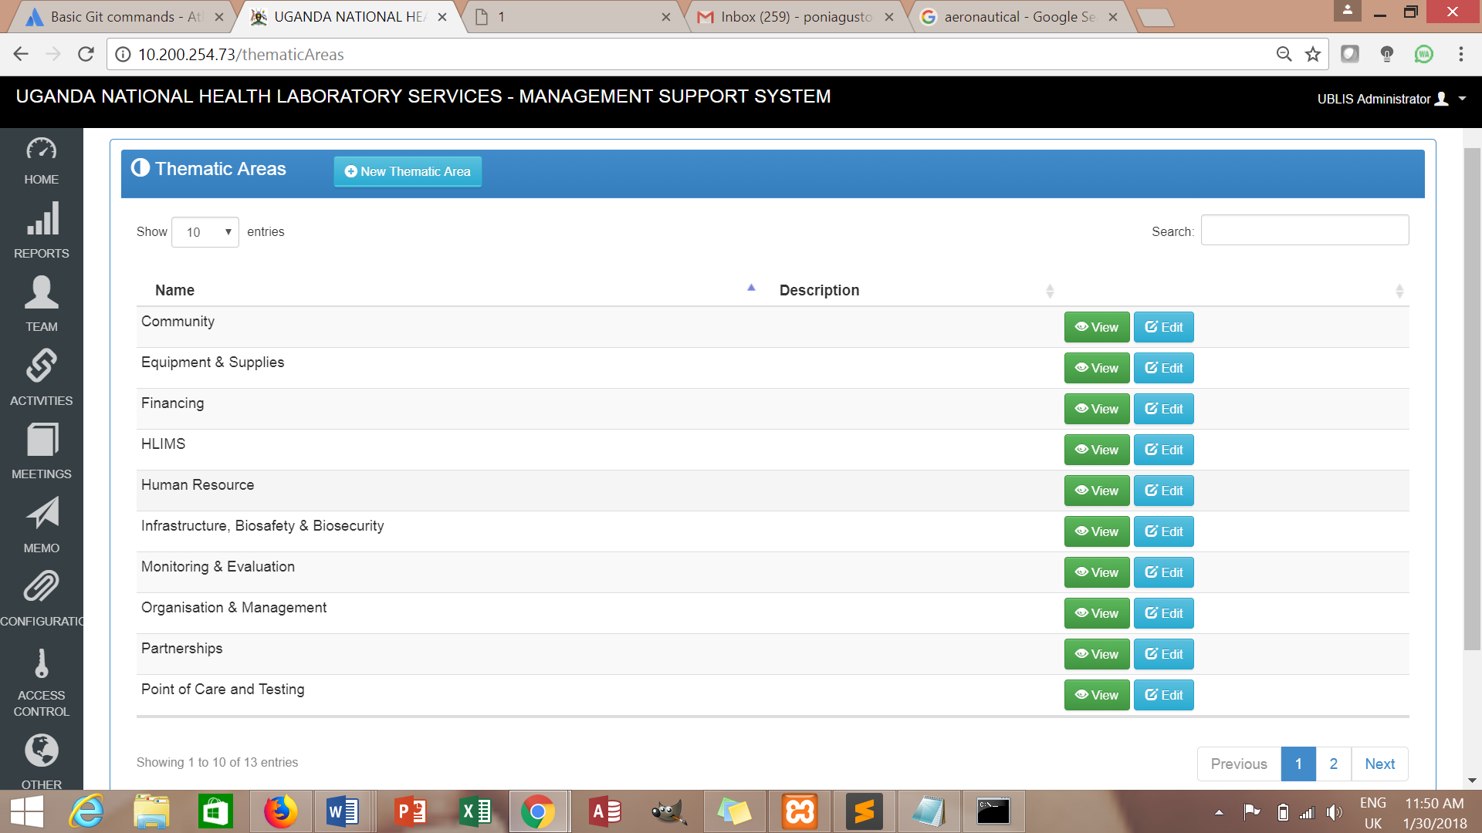

Fill in the form below and **save**

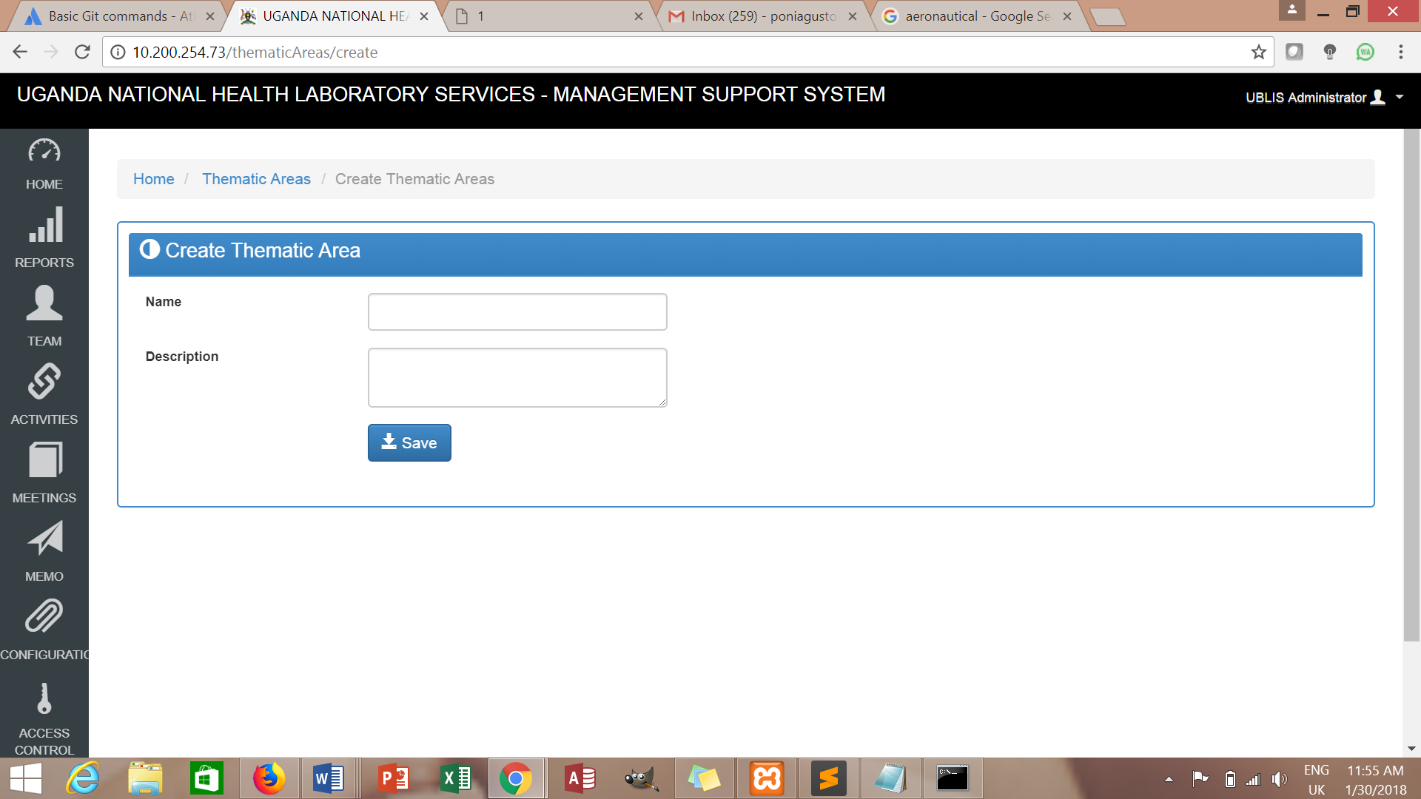

**Creating a Health Region**

Click  on the left menu bar, then click on  and click on Create Healthregion

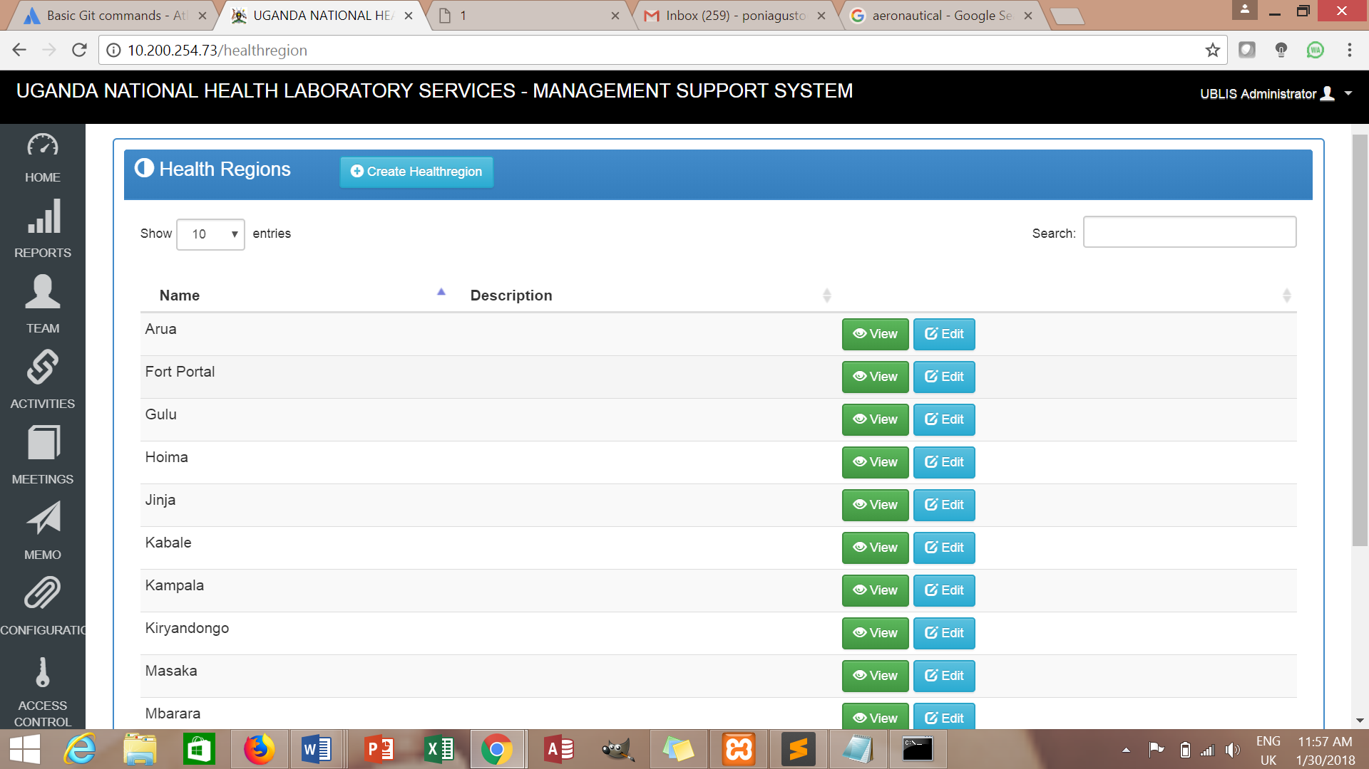

Fill in the form below and **Save**

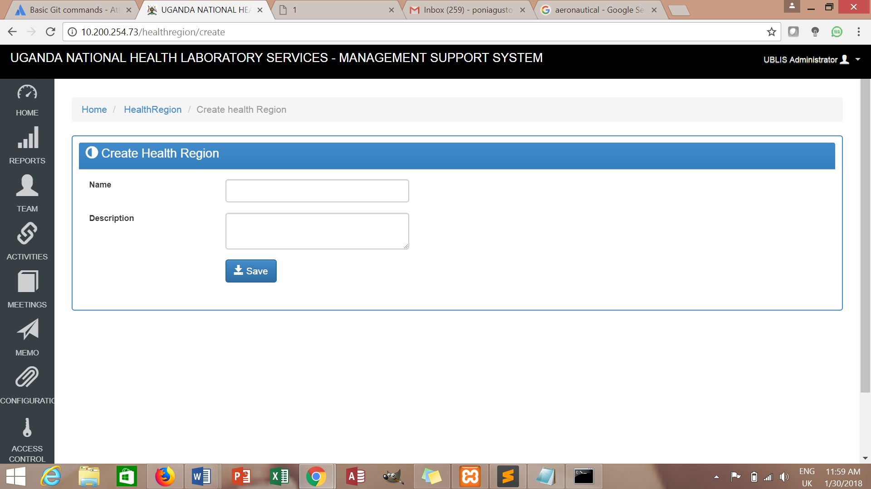

**Creating an Organiser**

Click  on the left menu bar, then click on  and click on Create new Organiser

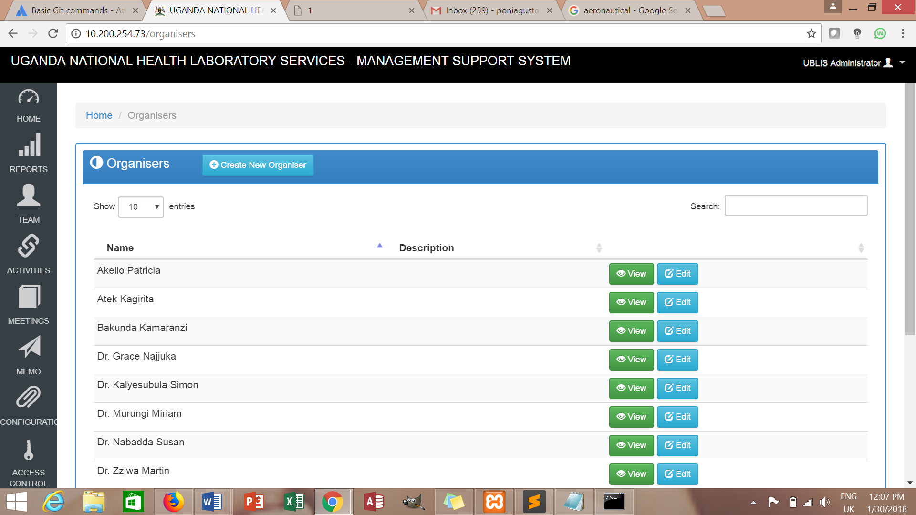

Fill in the form below and **save**

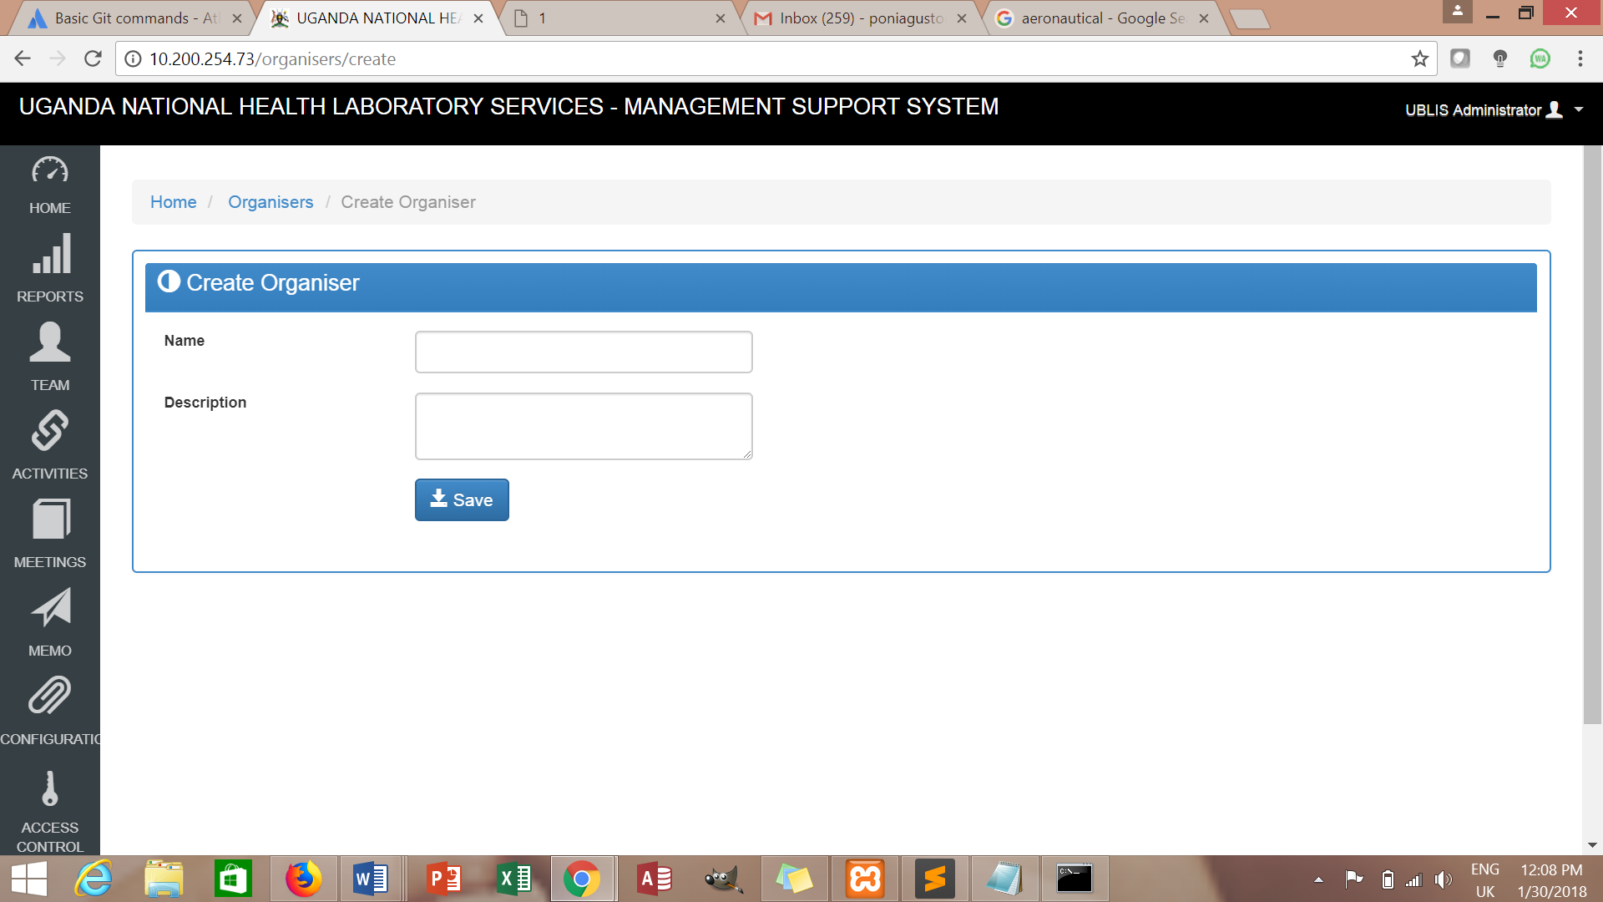

**Creating a Funder**

Click  on the left menu bar, then click on  and click on Create Funder

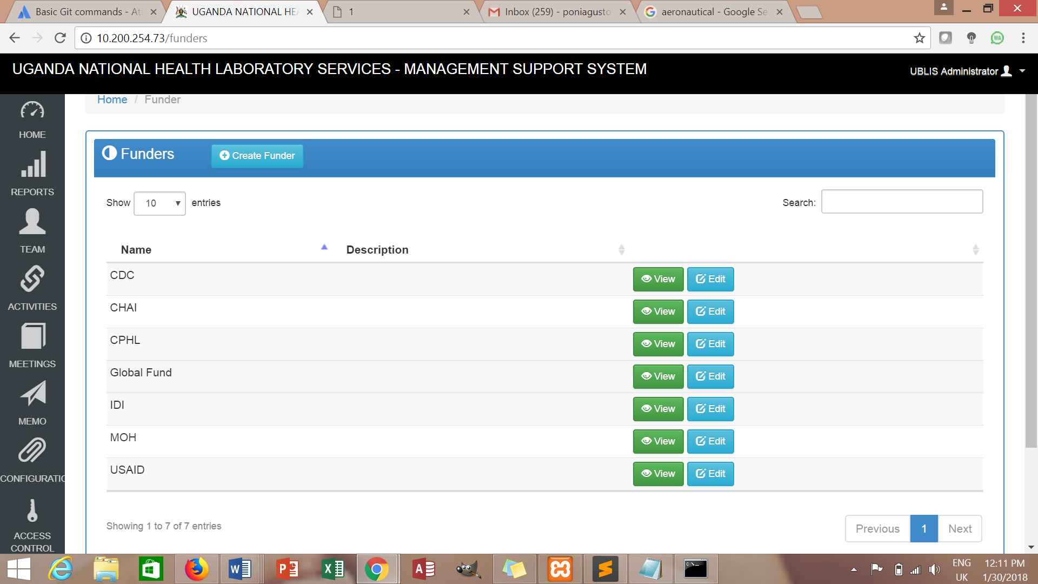

Fill in the form below and **Save**

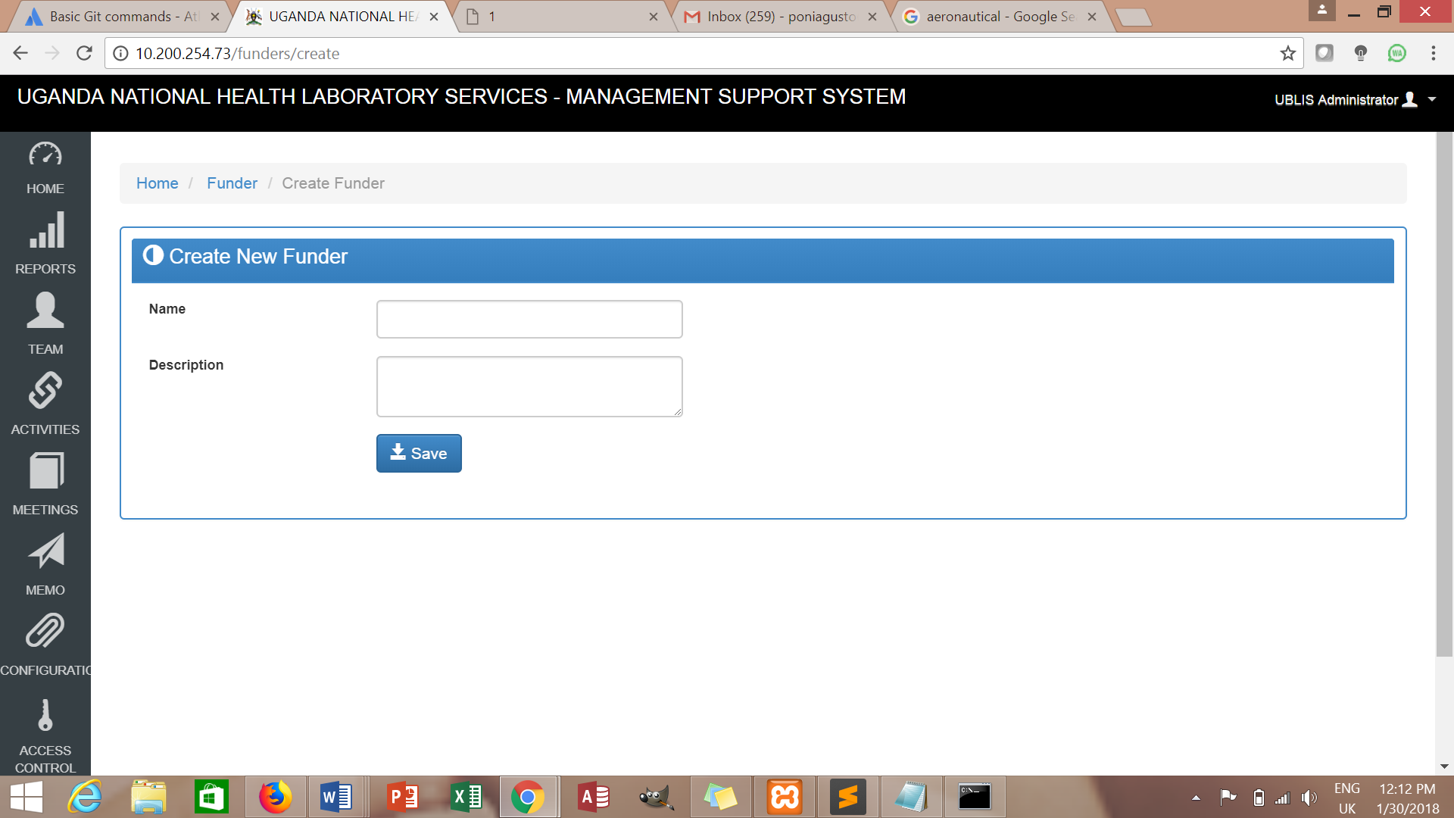

**Management team**

Click  on the left menu bar, then the list will be displayed.

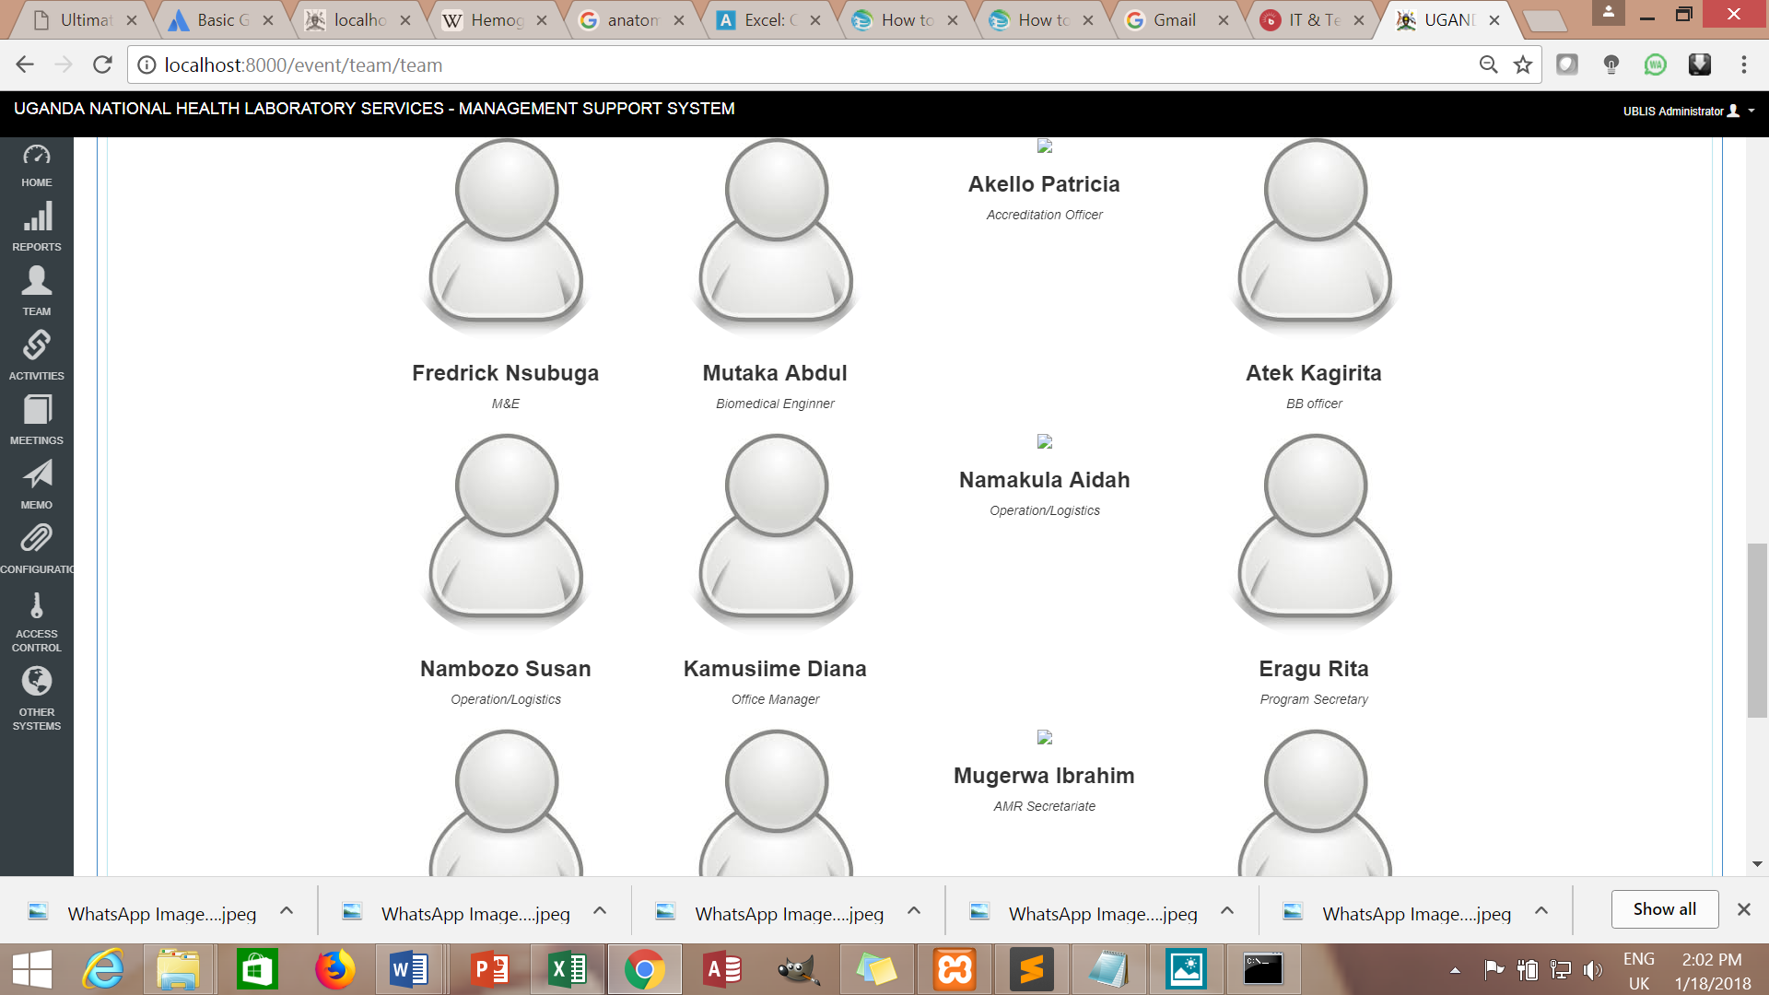

**Registering a new Activity**

Click  from the landing page, then click on the (circled) button at the

top of the blue port-let to register a new activity.

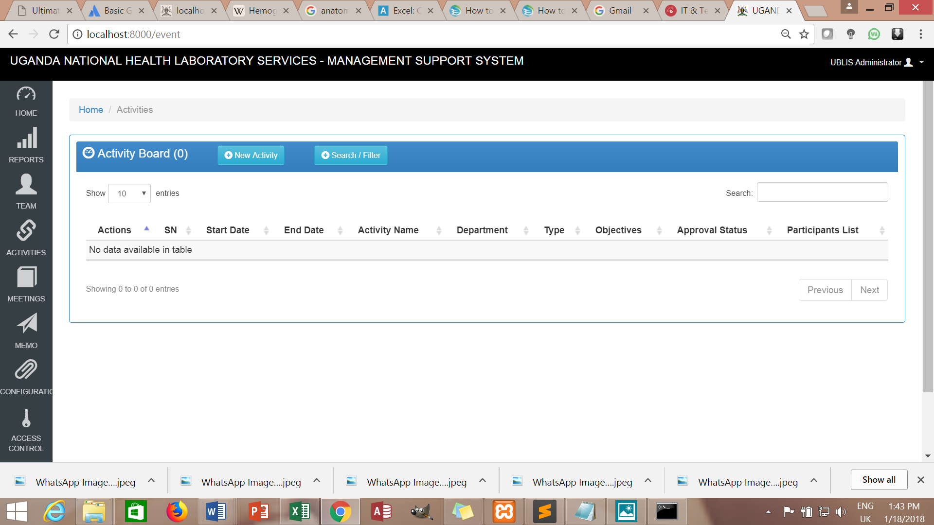

OR



This will bring a page with fields for capturing activity details. Enter information in the fields provided and click  to save the information captured as illustrated below

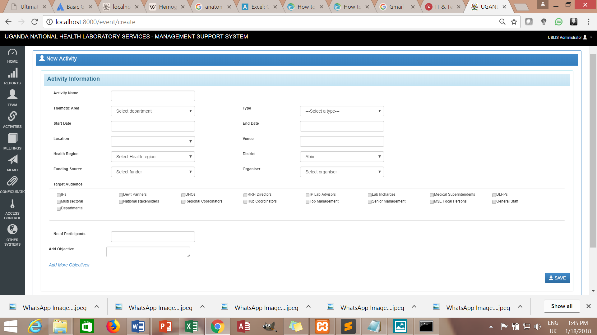

**Actions for a registered activity**

These actions are carried out after an activity has been registered in the system.

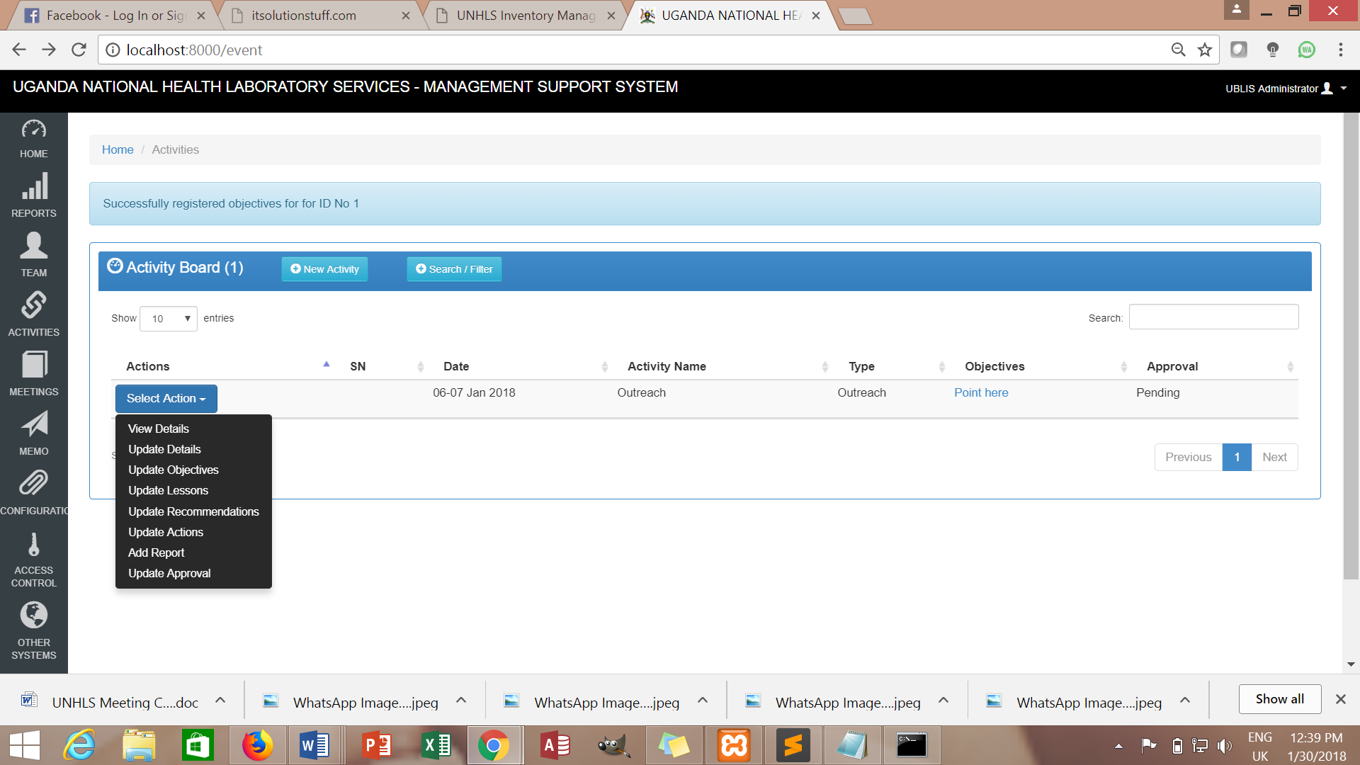

View Details

* Displays all captured information as regards the particular activity

Update Details

* Is for editing/ making adjustments for the activity

Update Objectives

* Add more objectives

Update Lessons

* Add leasons learnt from the activity

Update Recommendations

* Add the recommendations from the activity

Update Actions

* Add the action points, person responsible, date and location

Add Report

* Attach the final report from the activity

Update Approval

* Change activity status.

**Search/Filter**

Click on the encircled button to filter out desired data.

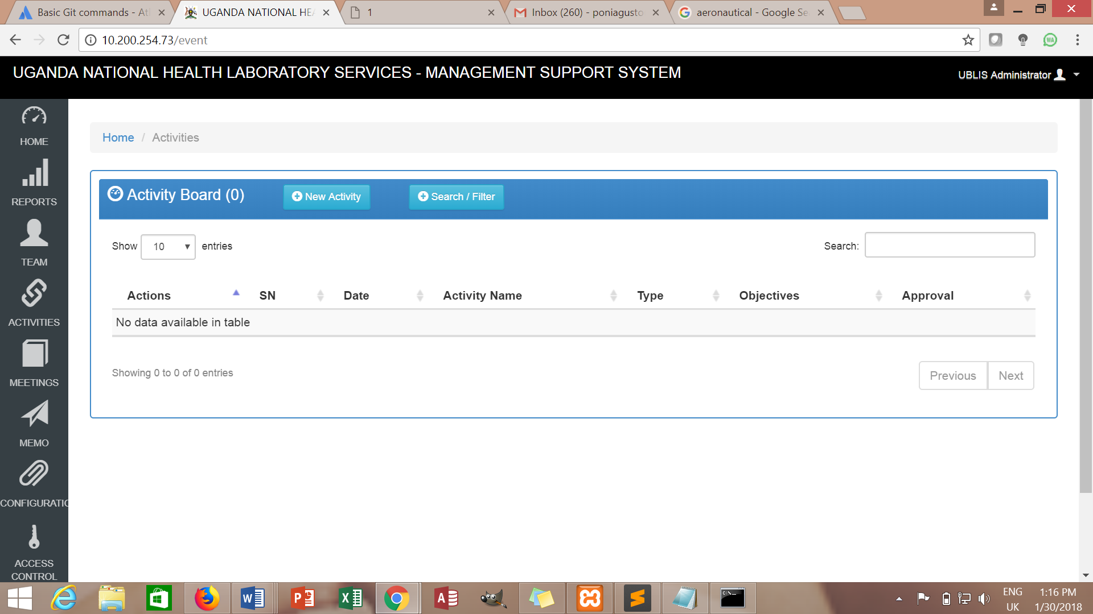

Fill in the required fields and filter

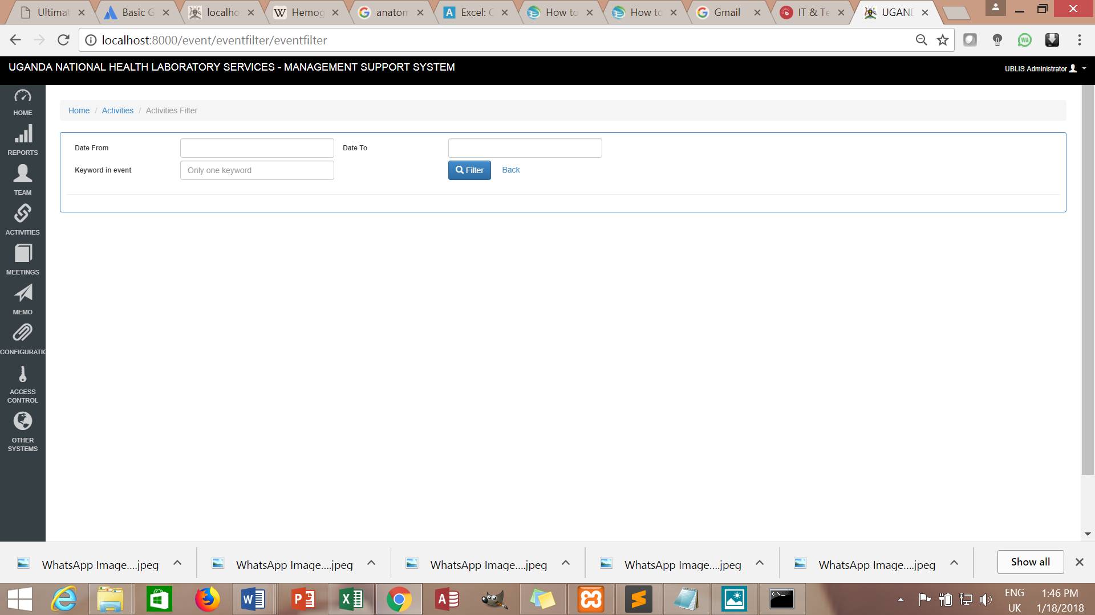

**Registering a meeting**

Click  from the landing page, then click on the encircled button at the

top of the blue port-let to register a new meeting. One can also **View** details of a meeting, **Edit**, **Attach minutes** and **Approve** on the meeting status.

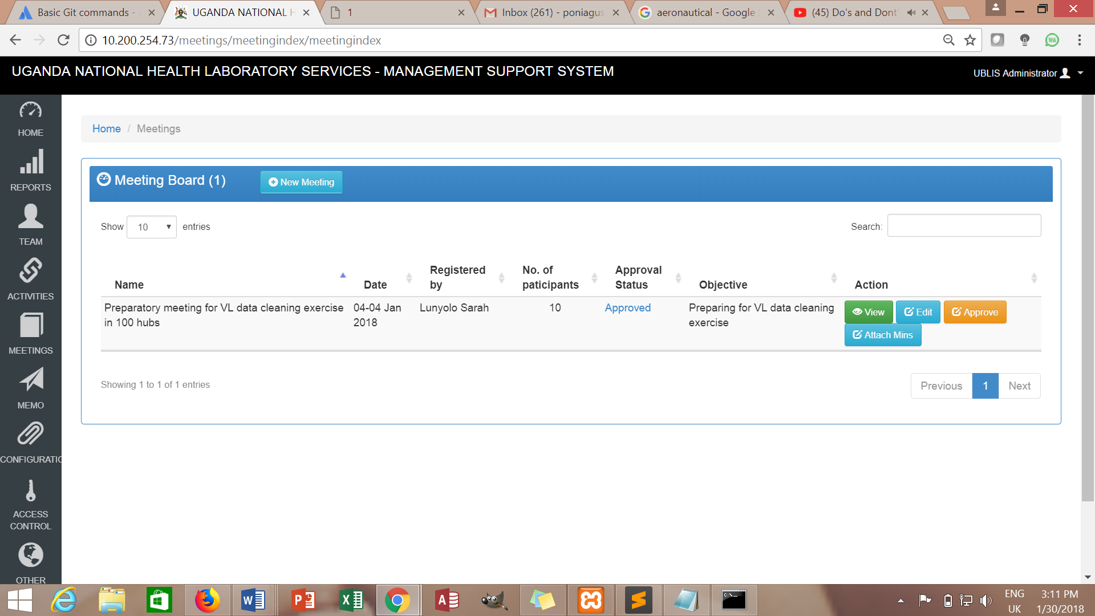

This will bring a page with fields for capturing meeting details. Enter meeting information in the fields provided and click  to save the information captured as illustrated below

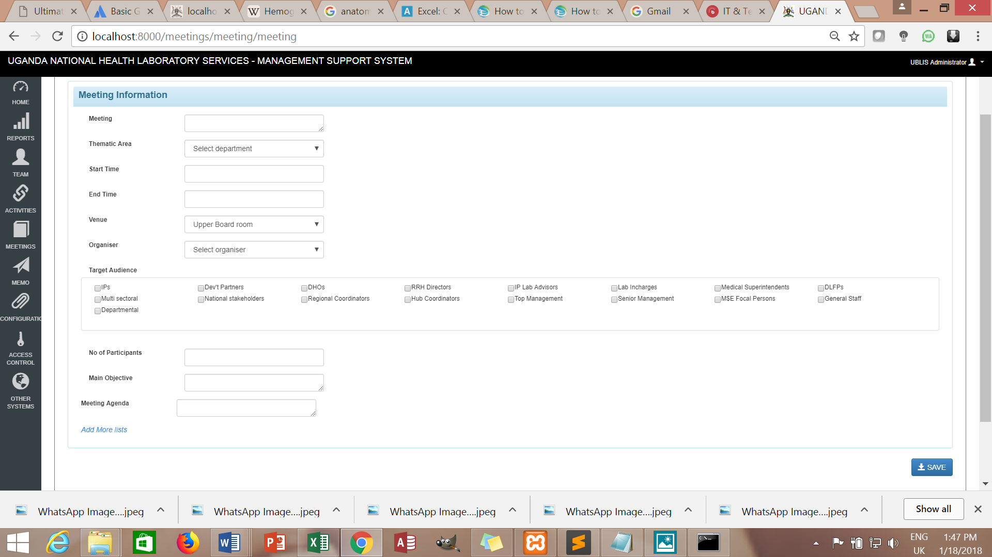

**Registering a new Memo**

Click  from the landing page, then click on the encircled button at the

top of the blue port-let to register a new memo.

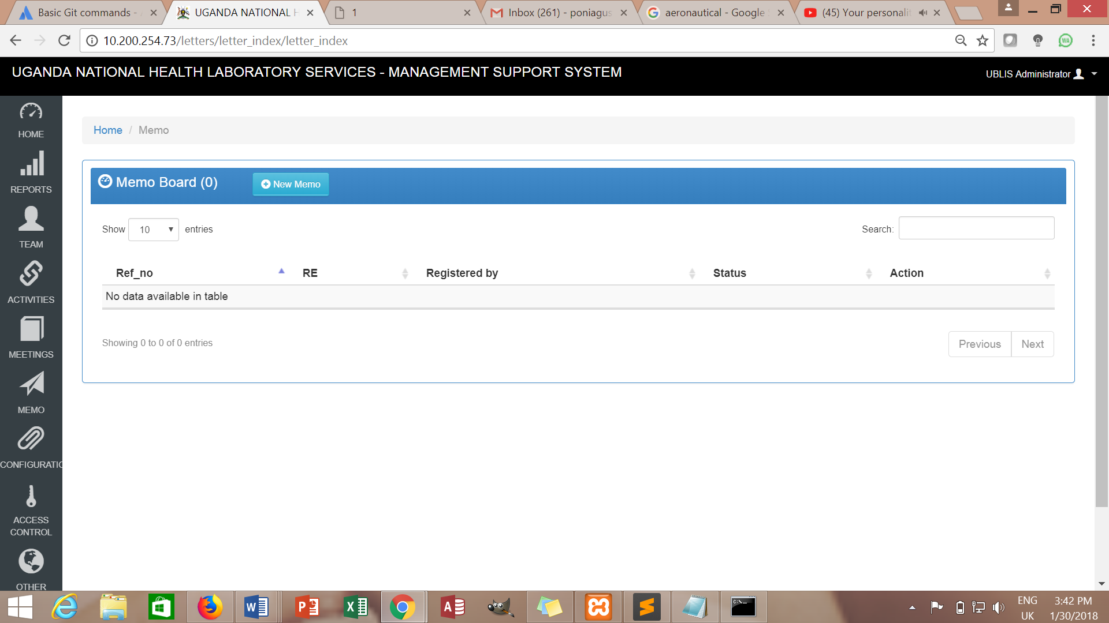

This will bring a page with fields for capturing memo details. Enter memo information in the fields provided and click  to save the information captured as illustrated below

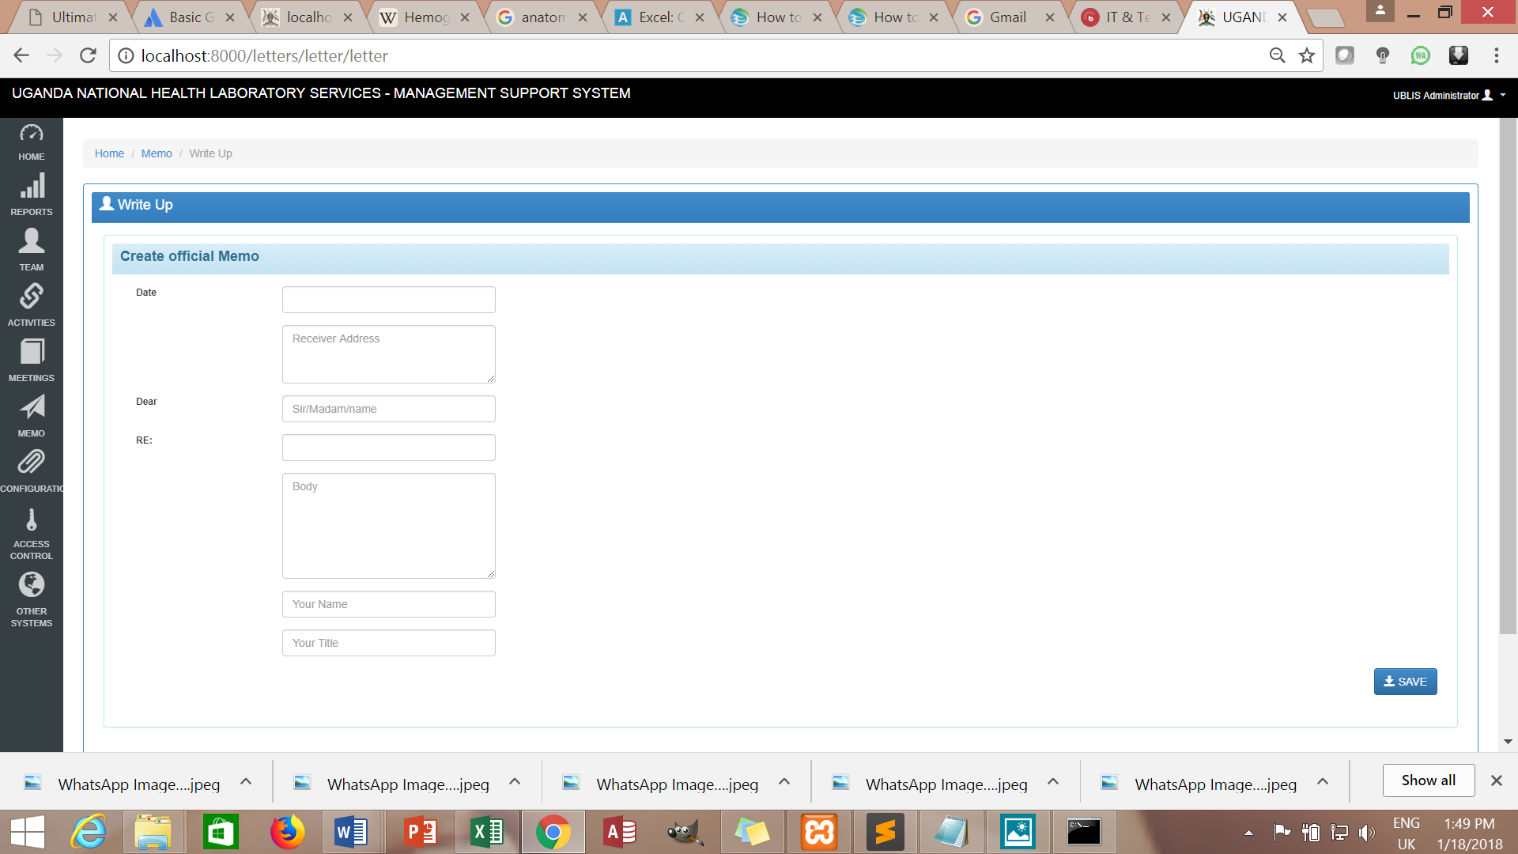

**Registering a new invitation**

Click  from the landing page, then click on the encircled button at the

top of the blue port-let to register an invitation.

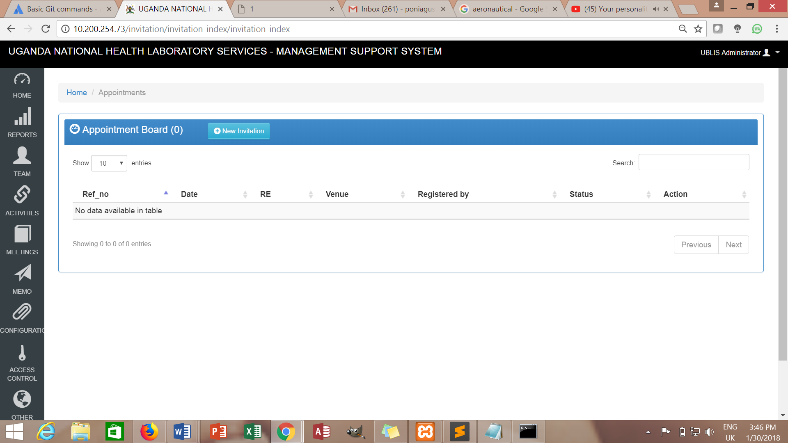

This will bring a page with fields for capturing invitation details. Enter information in the fields provided and click  to save the information captured as illustrated below.

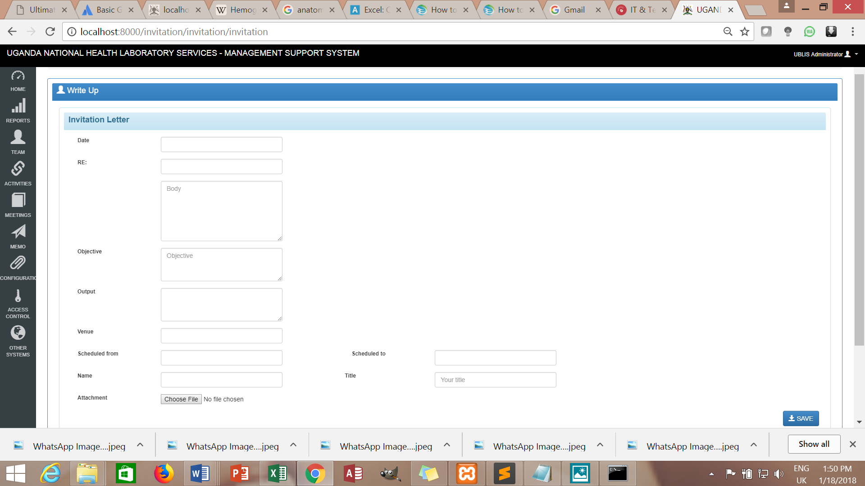

**View and download Report**

Reports have a summary of the captured information on the View Report and an attachment of the fieldwork/meeting report/minutes.

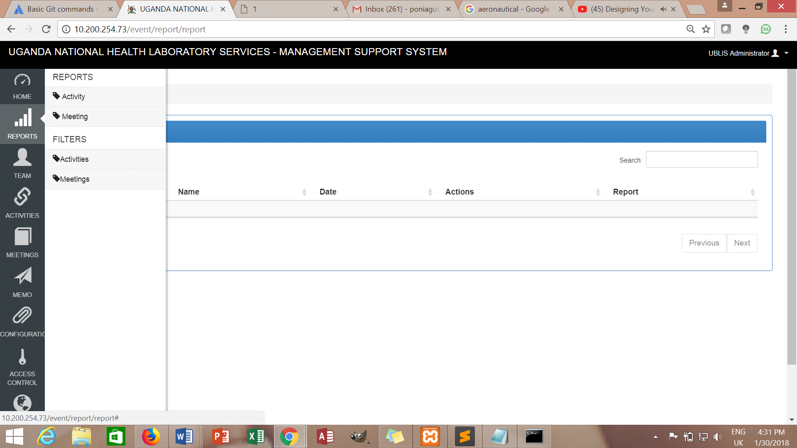

Activity report

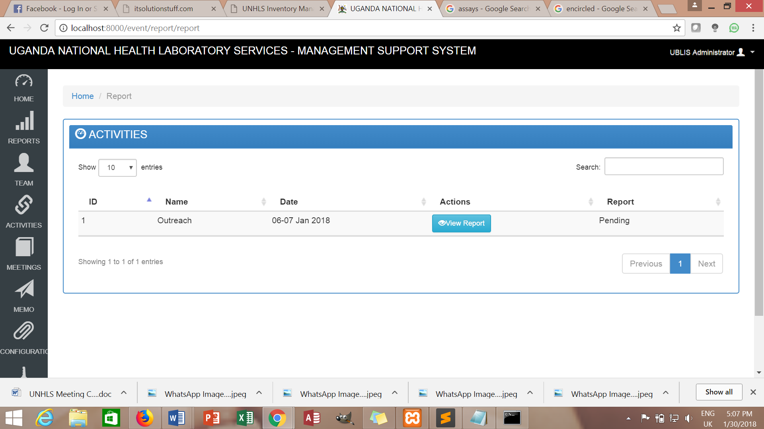

Meeting report

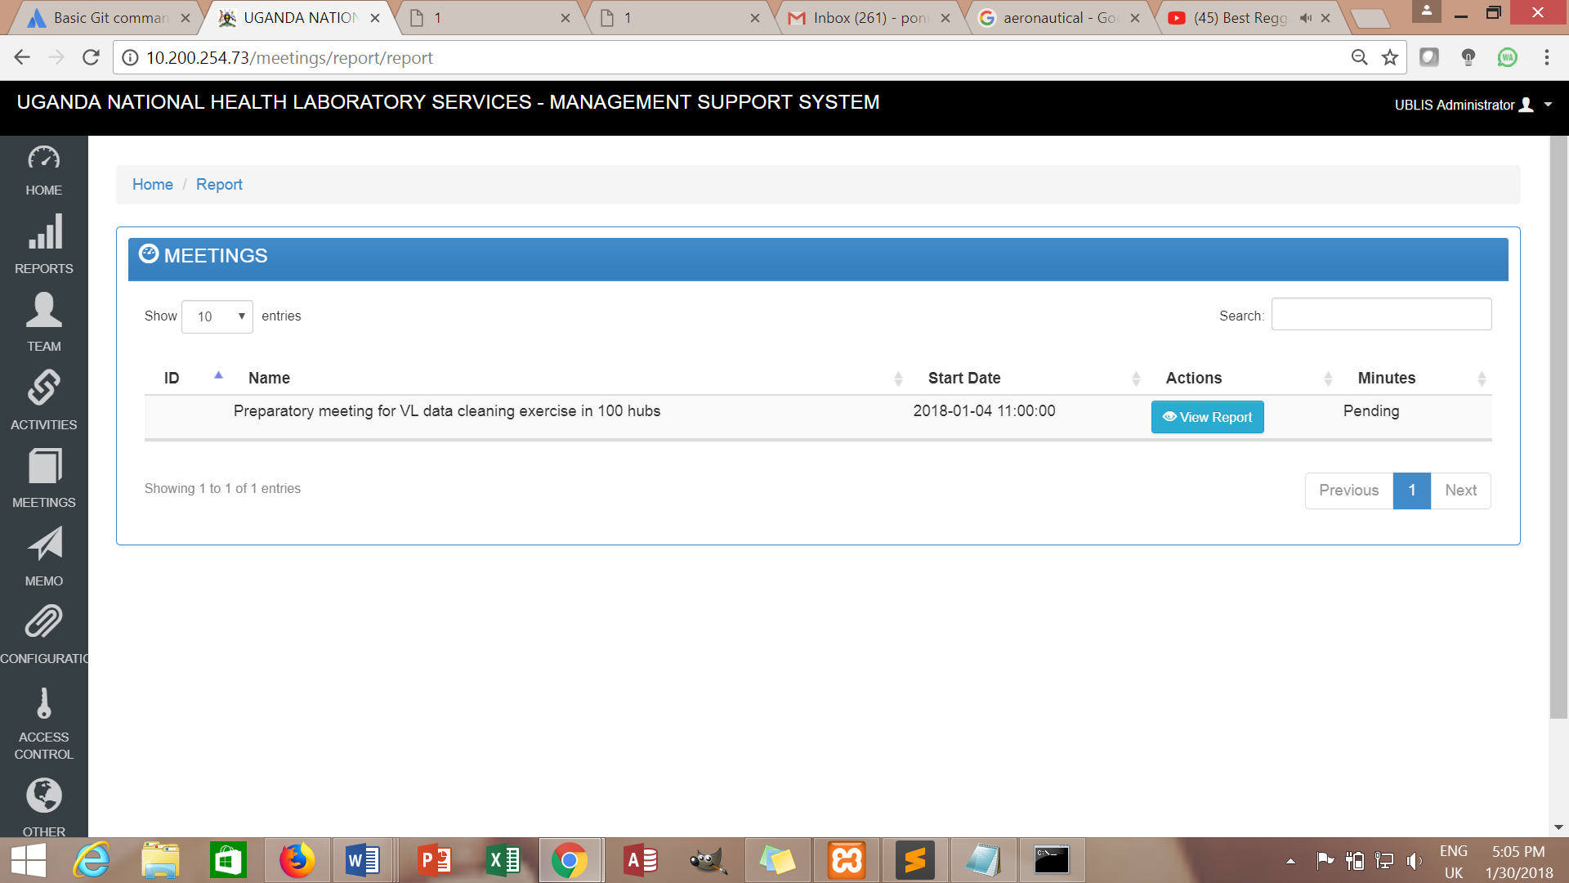

**Filter Reports**



Activities

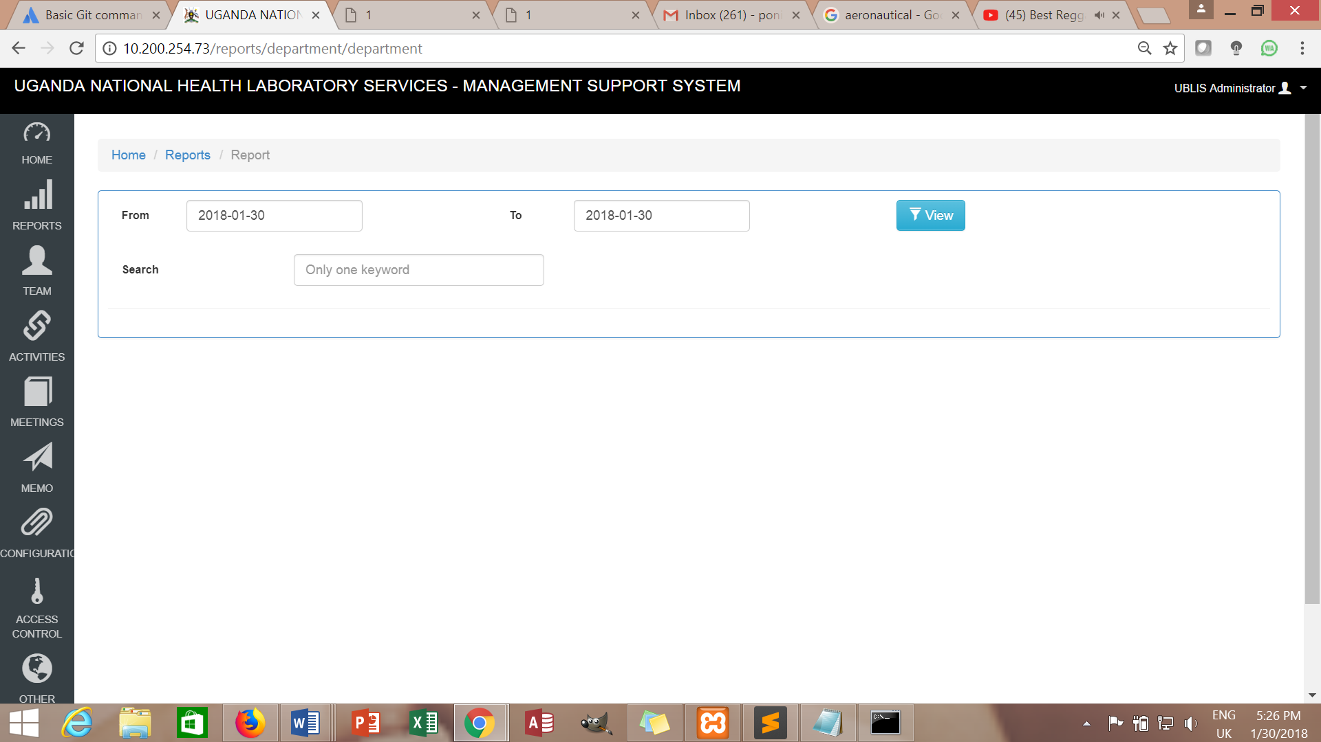

Meetings

